CS250 Lab 6 Assignment

Nicholas Donahue

# Analyzing N and Z bits of $cspr register.

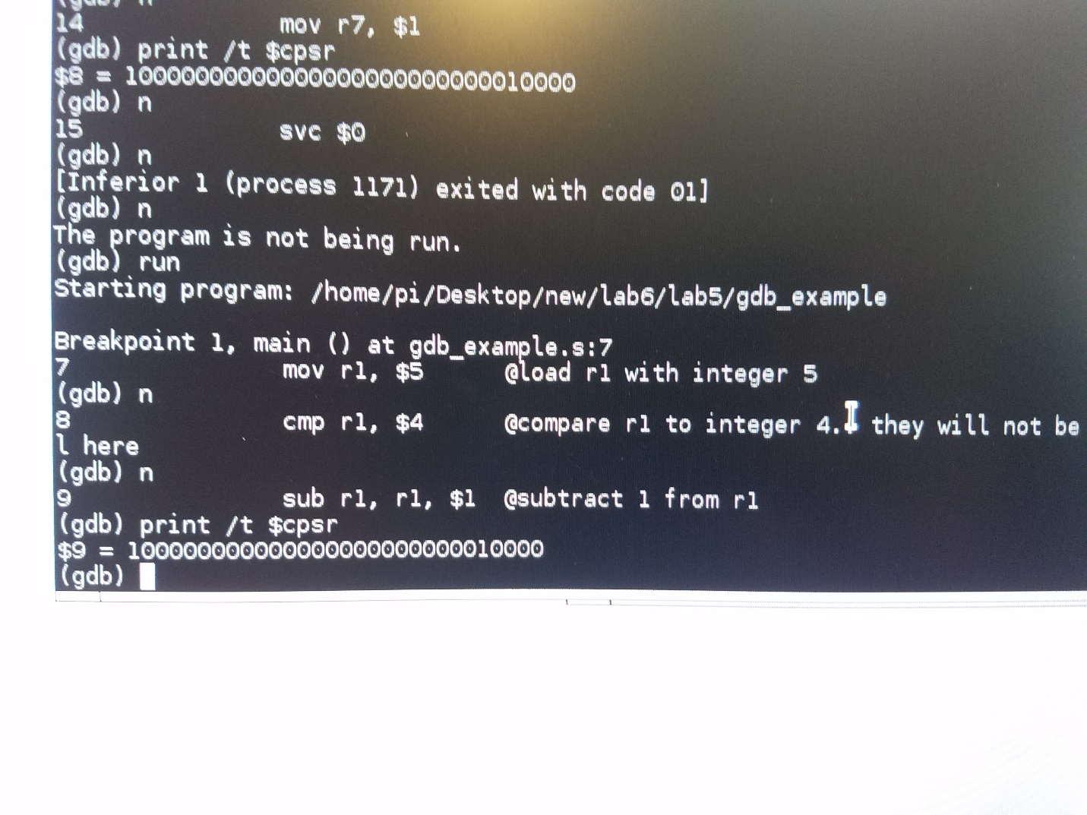

In this first ‘cmp’, both the N and Z bits are 0 (they are also not seen in the binary string above as they are the left most 2 bits and since they are both 0 they were hidden from the print statement). Both N and Z are 0 here because the cmp does not yield a negative number nor an equal comparison, each of which are required to trigger their respective flags.

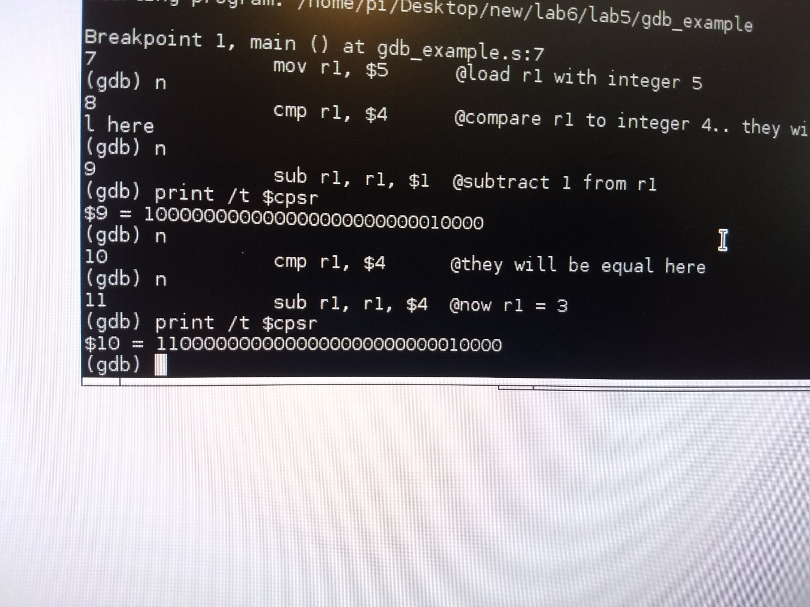

In this second ‘cmp’, N is 0 because the cmp does not yield a negative number and Z is 1 because the two integers being compared are equal. Similarly to the first print statement, the N bit is hidden in the print statement as it is the left-most bit and it is 0 so it is not displayed in the binary string.

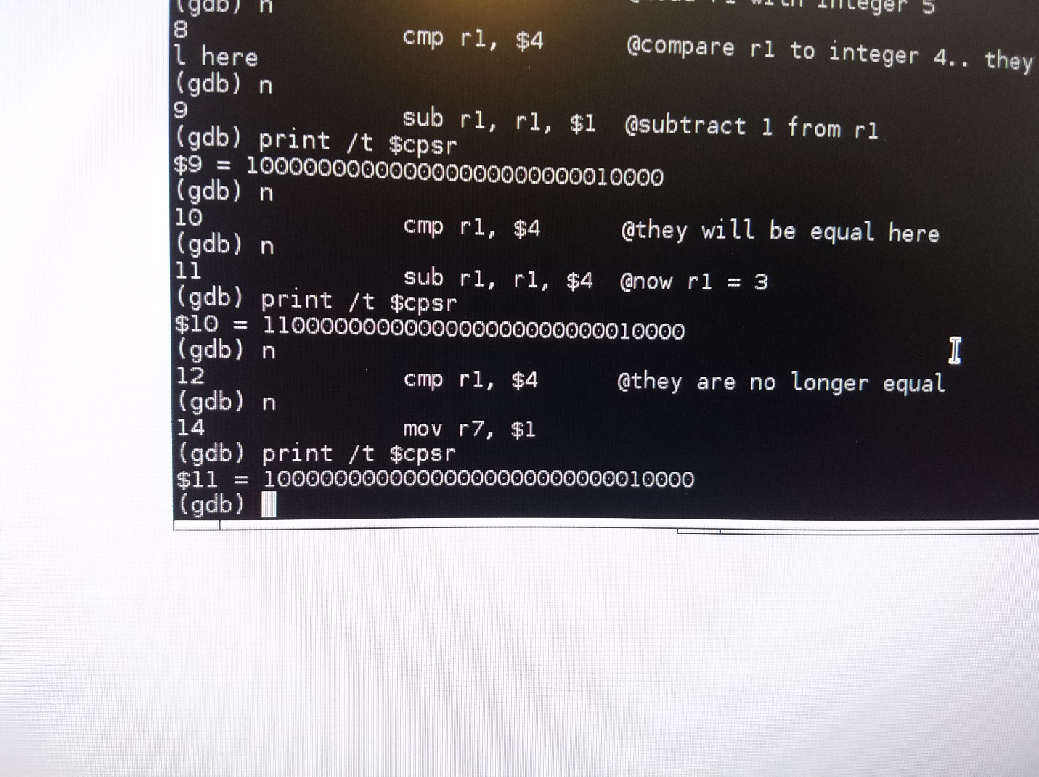

In this third and final ‘cmp’, N is 1 because the cmp yields a negative number from the operation (as it subtracts a constant value of 4 from a register value of 0 resulting in a negative number) and Z is 0 because the integers compared are not equal. Contrary to the above two screenshots, all 32 bits are present in this last screenshot and you can clearly see the N=1 and Z=0 as the to left-most bits in the printed binary string.